ETL Pipeline for H&M Data Analysis
- Project Overview
- Why This Project Was Needed
H&M, a global fashion retailer, accumulates large volumes of customer, product, and transaction data. To derive actionable insights from this data, it was necessary to implement an automated ETL (Extract, Transform, Load) pipeline that could:

- Centralize data from different tables
- Clean and preprocess data for analysis
- Store optimized data for business intelligence and machine learning tasks
Manually processing such vast data is time-consuming, error-prone, and inefficient. This project ensures a scalable, automated, and efficient data processing mechanism.
- What Exactly Was Done
The ETL pipeline was developed using Apache Airflow to:
  - Extract: Retrieve raw data from PostgreSQL tables.
  - Transform: Clean, preprocess, and structure data for analysis.
  - Load: Store transformed data into PostgreSQL for further use.
- Technology Stack
- Apache Airflow: Orchestrating ETL tasks
- PostgreSQL: Source and destination database
- Pandas: Data manipulation and transformation
- Docker: Containerized execution
- Python: Implementation language
- Dataset
- Articles Table
- article_id – A unique identifier for each product.
- product_code – The code assigned to a product, which may have multiple variations (like different colors).
- prod_name – The name of the product (e.g., "Bowtie Kalle").
- product_type_no – A numeric code representing the type of product.
- product_type_name – The name corresponding to the product type (e.g., "Tie," "Shirt").
- product_group_name – The broad category the product belongs to (e.g., "Accessories," "Garment Upper body").
- graphical_appearance_no – A numeric identifier for the graphical appearance of the product.
- graphical_appearance_name – The name of the graphical design (e.g., "Solid," "Striped").
- colour_group_code – A numeric code representing the color group.
- colour_group_name – The general color name (e.g., "Red," "Blue," "Dark Blue").
- perceived_colour_value_id – A numeric ID for the perceived color intensity or shade.
- perceived_colour_value_name – The description of the color intensity (e.g., "Dark," "Medium").
- perceived_colour_master_id – A numeric ID representing the dominant color family.
- perceived_colour_master_name – The name of the dominant color (e.g., "Blue," "Red").
- department_no – A numeric code representing the department within the store.
- department_name – The department where the product is categorized (e.g., "Menswear," "Lingeries/Tights").
- index_code – A code representing a subcategory within a department.
- index_name – The name of the index/subcategory (e.g., "Ladieswear," "Menswear").
- index_group_no – A numeric identifier for the index group.
- index_group_name – The name of the broader index group (e.g., "Men Accessories," "Womens Everyday Basics").
- section_no – A numeric identifier for a section within a department.
- section_name – The section where the product is placed (e.g., "Men Accessories," "Womens Lingerie").
- garment_group_no – A numeric ID for the garment group.
- garment_group_name – The category of clothing (e.g., "Accessories," "Under-, Nightwear").
- detail_desc – A textual description of the product, including materials, design, and features.
- Transactions Table
- T_dat – The transaction date when the purchase was made.
- customer_id – A unique identifier for the customer who made the purchase.
- article_id – The unique identifier for the purchased product.
- price – The price of the product at the time of purchase.
- sales_channel_id – The sales channel through which the product was purchased (e.g., 1 for online purchases, 2 for physical stores).
- Customers Table
- customer_id – A unique identifier for each customer.
- FN – A flag indicating whether the customer is part of a specific loyalty program (1 for yes, NaN for no).
- Active – A flag indicating whether the customer is actively engaging with the company (1 for active, NaN for inactive).
- club_member_status – The membership status of the customer (e.g., "ACTIVE", "PRE-CREATE", "LEFT CLUB").
- fashion_news_frequency – How frequently the customer receives fashion-related news ("Regularly", "Monthly", "None", etc.).
- age – The age of the customer.
- postal_code – The postal code of the customer’s residence.

- Pipeline Workflow
- Extract Data
The pipeline extracts data from PostgreSQL tables:
- Articles
- Customers
- Transactions
These tables are read using SQL queries and stored in temporary tables:
- temp_articles
- temp_customers
- temp_transactions
This ensures data is extracted without modifying the original source tables.
- Transform Data
Data transformation includes:
- Articles Table:
- Converting article_id to int data types.
- Renaming columns for clarity.
- Dropping irrelevant columns (product_type_no, graphical_appearance_no, etc.).
- Removing duplicate records.
- Customers Table:
- Removing duplicates.
- Converting customer_id to string data types.
- Filling missing values (club_member_status, fashion_news_frequency).
- Dropping irrelevant column (postal_code).
- Creating Age_Group column for segmentation.
- Converting categorical values (club_member_status) to numeric format.
- Filling up empty strings in column (club_member_status).
- Transactions Table:
- Converting article_id and customer_id to appropriate data types.
- Formatting Transaction Date column to datetime and price column to float data type.
- Mapping sales channel IDs to readable values (Online/Offline).

- Adding a new season column based on transaction date.
Transformed data is stored in:
- temp_transformed_articles
- temp_transformed_customers
- temp_transformed_transactions

- Load Data
- Transformed data is loaded back into PostgreSQL in batches of 5000 rows for optimized performance.
- Final tables include:
- transformed_articles
- transformed_customers
- transformed_transactions
- DAG Implementation
Airflow DAG is structured as:
- Task 1: extract_data – Extracts data from PostgreSQL and stores it in temporary tables.
- Task 2: transform_data – Cleans and processes data for analysis.
- Task 3: load_data – Loads transformed data into final tables in PostgreSQL.
These tasks execute in sequence: Extract → Transform → Load
- Challenges Faced
- Handling Large Data Volumes: Optimized by using batch processing (5000 rows per batch).
- Data Cleaning Issues: Missing and inconsistent data were handled using Pandas functions.
- Pipeline Failures: Implemented XCom for inter-task communication and exception handling to prevent task failures.
- PostgreSQL Performance: Indexed transformed tables for faster query execution.
- Code Explanation
- Extract Data
- Uses PostgresHook to connect to PostgreSQL and retrieve tables.
- Saves extracted data into temporary tables.
- Passes table names to XCom for the next task.
- Transform Data
- Reads temporary tables and cleans data.
- Renames and removes unnecessary columns.
- Converts categorical values into numeric formats.
- Adds computed fields like Age_Group and season.
- Stores transformed data in PostgreSQL.
- Load Data
- Uses batch processing to efficiently load data.
- Replaces the table on the first batch, appends for subsequent batches.
- Implements error handling to catch failures.
- Exploratory Data Analysis
- Top 5 Selling Products by Age Group
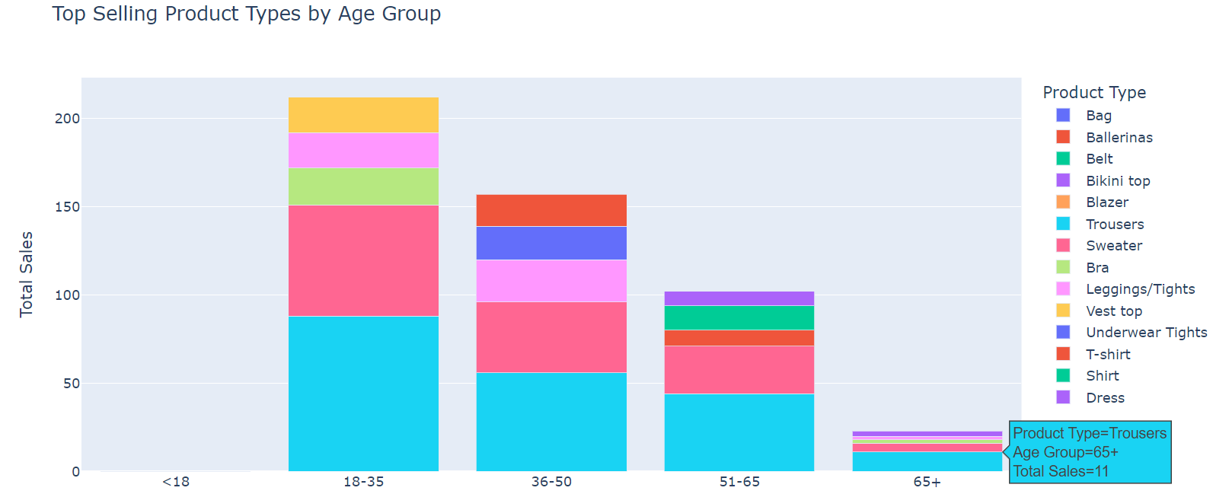
- Correlation between Customer Id and Club Member Status
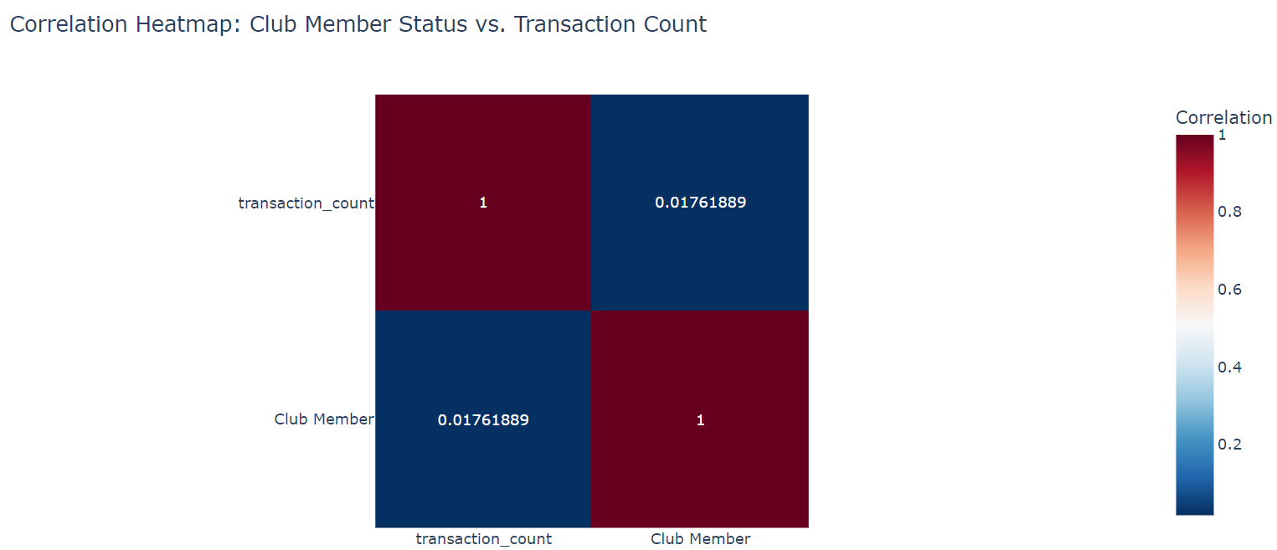
This suggests a low correlation between the Club Member Status and their spending rates
- Perecentage of Sales in each Channel
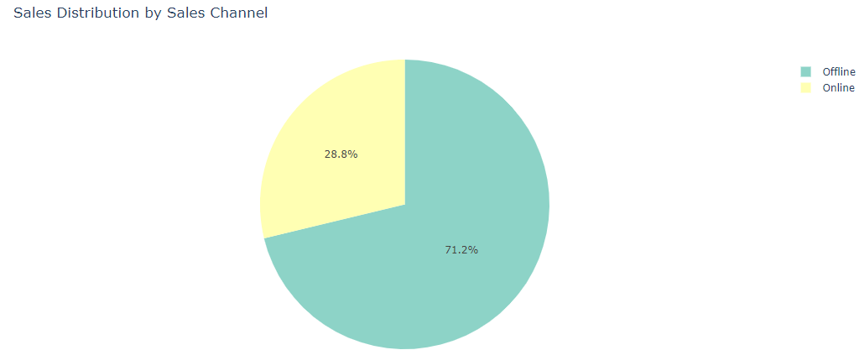
Sales Channel Proportion
0 Offline 0.712316
1 Online 0.287684
- Top 5 Best Selling Products

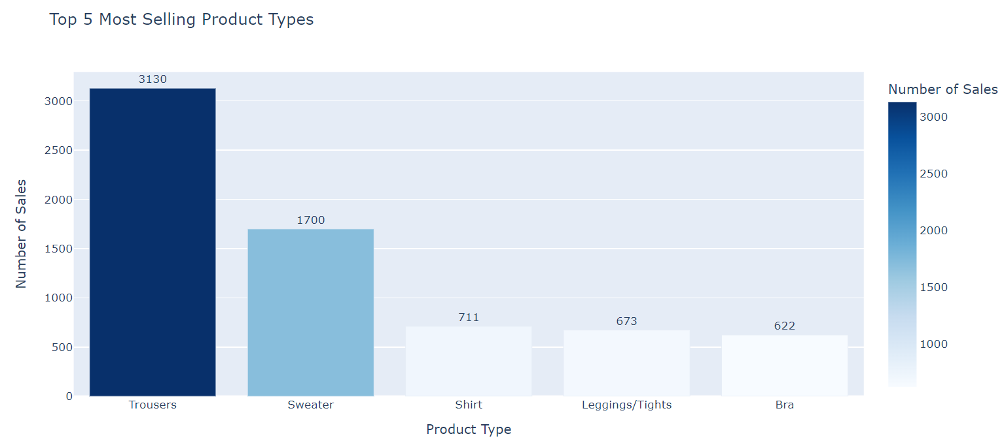
Top Selling product is Trousers.

- Conclusion
This ETL pipeline efficiently extracts, cleans, and loads H&M data, making it ready for further business analysis. It follows best practices for data transformation and is optimized for handling large datasets. The use of Airflow, batch processing, and exception handling ensures a scalable and fault-tolerant workflow.

